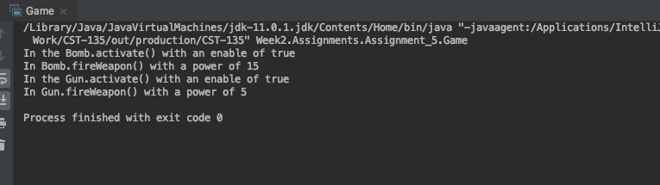

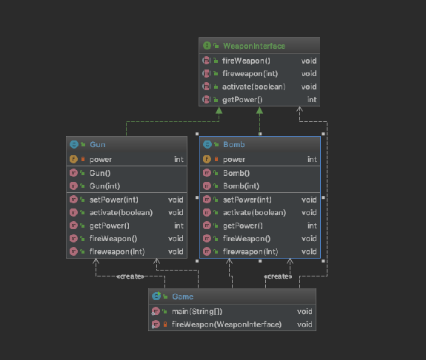

In this exercise I was able to execute and show polymorphism through an interface class. With an interface class, all methods have to be predefined on what they can do. I was struggling with my getPower() method and then moved it to the interface as it could be used by both weapon classes. In doing so and overriding it to return this.power that is set by the constructer, I can then loop through each weapon and their power level. In this case common classes can be defined by the interface and will need to be implemented by any weapon going forward. This way you can ensure that each weapon has common methods needed to define what it can do.